Chapter 19, Solution 10.

- This is a non-reciprocal circuit so that the two-port looks like the one shown in Figs. (a) and (b).
z₁₁
z₂₂
z₁₂ I₂
z₂₁ I₁
(a)
+
V₂
−
+
−
I₁
I₂
+
V₁
−
+
−

25 
10 
20 I₂
5 I₁
(b)
+
V₂
−
+
−
I₁
I₂
+
V₁
−
+
−

- This is a reciprocal network and the two-port look like the one shown in Figs. (c) and (d).
z₁₁ – z₁₂
z₂₂ – z₁₂
z₁₂
(c)
+
V₂
−
I₁
I₂
+
V₁
−

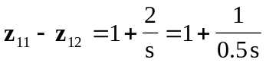
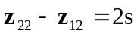
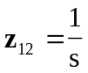
(d)
+
V₂
−
I₁
I₂
+
V₁
−
2 H
1 F
0.5 F
1 

